Lab Manual 5 – Lab Tasks 1 to 4

By Faizan Ahmad 476602

Section A

Task 1:

Code:

#include<iostream>

#include<math.h>

using namespace std;

int main() {

int x;

do {

cout<<"Enter a number: ";

cin>>x;

} while ( x > 0 );

return 0;

}

Screenshot of execute:

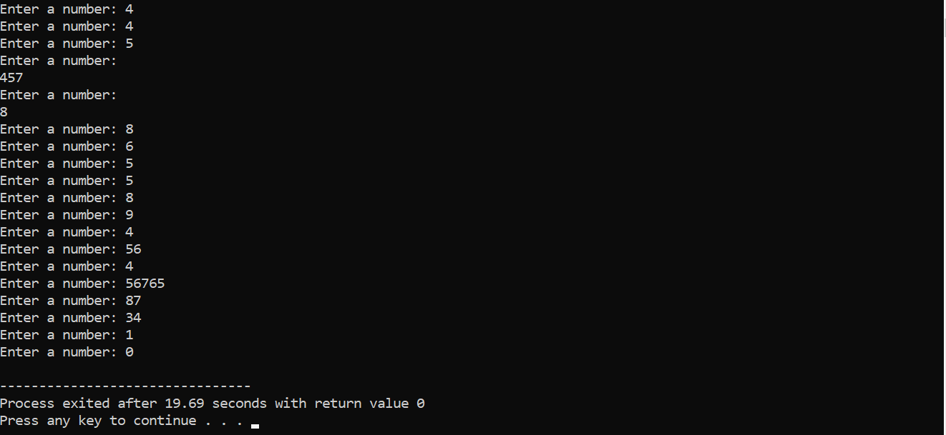

Task 2:

Code:

#include<iostream>

#include<math.h>

using namespace std;

int main() {

char choice;

double x, y;

double result;

do {

cout << "Enter first number: ";

cin >> x;

cout << "Enter an operator (+, -, \*, /, %, ^): ";

cin >> choice;

cout << "Enter second number: ";

cin >> y;

switch (choice) {

case '\*' : {

result = x \* y;

break;

}

case '/' : {

result = x / y;

break;

}

case '+' : {

result = x + y;

break;

}

case '-' : {

result = x - y;

break;

}

case '%' : {

result = fmod( x,y );

break;

}

case '^' : {

result = pow( x,y );

break;

}

default : {

cout<<"Your opperator is invalid"<<endl;

break;

}

}

cout << "Result: " << x << " " << choice << " " << y << " = " << result << endl;

cout << "Do you want to perform another calculation? (y/n): ";

cin >> choice;

} while (choice == 'y' || choice == 'Y');

return 0;

}

Screenshot of execute:

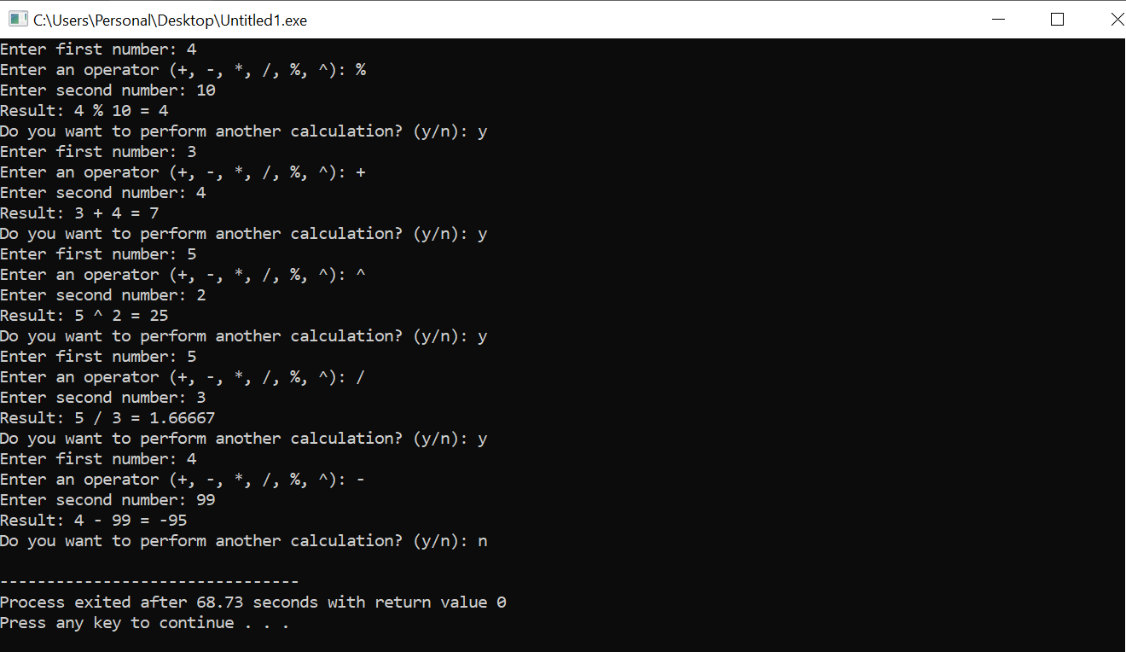

Task 3, Part ‘a’:

Code:

#include<iostream>

#include<math.h>

using namespace std;

int main() {

int sum = 0, x = 0;

cout<<"Part a"<<endl;

do {

if ( x % 2 == 0 && x != 0 && x != 1) {

sum = sum + x;

}

x++;

} while ( x < 101 );

cout<<"The sum of all even numbers between 0 to 100 is:"<<sum;

return 0;

}

Screenshot of execute:

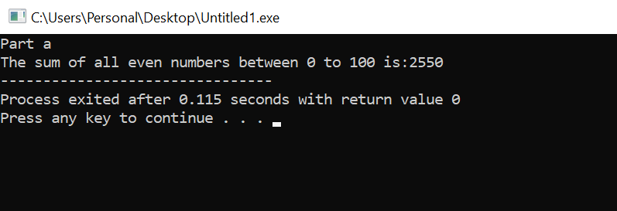

Part ‘b’

Code:

#include<iostream>

#include<math.h>

using namespace std;

int main() {

int sum = 0;

int x = 0;

double y;

cout<<"Part b"<<endl;

do {

y = pow(x,2);

sum = sum + y;

x++;

} while (x<101);

cout<<"The sum of all perfect squares between 1 and 100 is: "<<sum;

return 0;

}

Screenshot of execute:

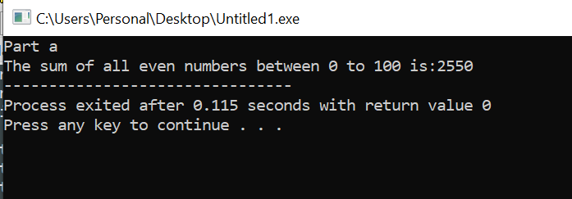

Task 4, Part ‘a’

Code:

#include<iostream>

#include<math.h>

using namespace std;

int main() {

double x = 0;

do {

cout<< pow( 2,x )<<" ,";

x++;

} while ( x <= 20 );

return 0;

}

Screenshot of execute:

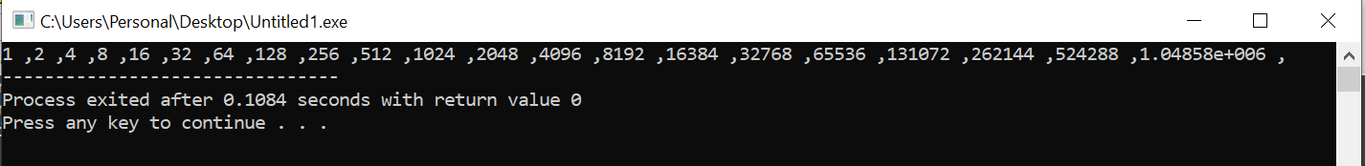

Part ‘b’

Code:

#include<iostream>

#include<math.h>

using namespace std;

int main() {

int a, b, sum;

cout<<"Enter numbers a and b"<<endl;

cin>>a>>b;

do {

if ( a % 2 == 1 ) {

sum = sum + a;

}

a++;

} while ( a <= b);

cout<<"The sum of all odd numbers between a and b is: "<<sum;

return 0;

}

Screenshot of execute:

